Case 1-Eur-Bulgaria-Neolithic-Ceramic Idol-6th Millennium BCE-51 mm

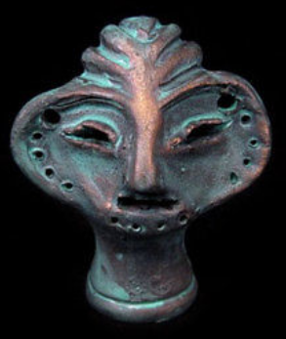

**Formal Label: Bulgaria** Neolithic Ceramic Idol 6th Millennium BCE

**Accession Number:**

**LC Classification:**  GN776.B9

**Date or Time Horizon:** 6th Millennium BCE

**Geographical Area:** Stara Zagora, Bulgaria

**Cultural Affiliation:** Neolithic.

**Medium:** Original, ceramic; replica is made of a ceramic material and painted with special varnish and paint.

**Dimensions: H** 51 mm; W 44 mm. **Weight: 14 gm**

**Provenance:** The Original was found in the ruins of a Neolithic settlement in the region of Stara Zagora, Bulgaria. This is a restored reproduction. The original is in the Stara Zagora Museum.

**Condition:** Museum replica.

**Discussion:** These Stara Zagora heads are unique and represent the differentiation f communities as they expressed their singular artistic and mythological ideas in ceramics (Gaul 1948).

**References:**

Gaul, James Harvey. 1948. **The Neolithic period in Bulgaria. Bulletin (American School of Prehistoric Research), no. 1. Cambridge, MA.: American School of Prehistoric Research.**